Painting System by Abracadabra

03/25/2017

UO Phoenix: [www.ultimaonlinephoenix.com](http://www.ultimaonlinephoenix.com)

Special thanks to Danzar for his skill and assistance with completing this project.

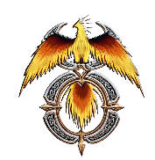

The Painting System is designed to allow players to create unique and customized paintings and portraits of items they see in game. Each creation denotes the subject and artist of the work, allowing for near endless potential!

Portraits – Players can either make a self-portrait, or a portrait of another player. They must choose the sex appropriate image to complete the work.

Still Lifes – These painting types are meant to be of virtually anything in the game, even mobiles. Addons and Static objects are excluded as they do not render the object name properly.

Abstracts – These painting types can be of anything as well, but unlike Still Lifes their naming convention says “An abstract painting titled…”. These paintings can also not be used on Static or Addon objects.

Optional – Included in the package are Canvas.cs and Paintbucket.cs which are the materials needed to make any painting. I recommend adding these items into your Tailoring and Alchemist crafting as well as their respective NPC vendors.